

|  |  |  |  |  |  |  |  |  |
| --- | --- | --- | --- | --- | --- | --- | --- | --- |
|  | | | | | | | | |
|  | | Assignment . 5 | | | | |  | |
|  |  | | | | | | |  |
|  | | | |  |  | | | |
|  | | | | MujtabaSP22-BSE-036 |  | | | |
|  | | | | Nov 28, 2022—Introduction to Management—Mam Nabila Nazir |  | | | |
|  | | |  | | |  | | |

A Quality Control Method: Color Spots on Packages

Why do some packages have color packages?

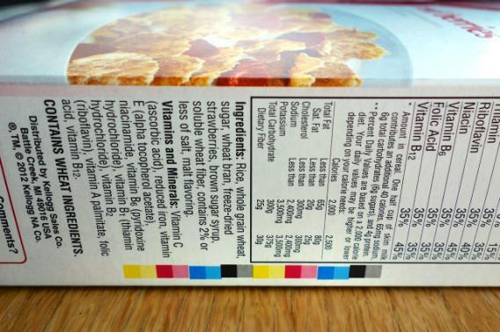In this article, the author mentions four potential reasons of why color pallets appear on food packages. He later confirms that one of the reasons is true:

Figure : Color spots on a package.

“Process control patches, or printer’s color blocks, are used to check the quality or density of colors that are used on the package”.

According to Bridget Christenson, PR manager for General Mills: “The color blocks are essentially a tool used to understand how a printer is printing at any moment in time to ensure consistency. The blocks provide very technical information about printing conditions that allow printers to quickly adjust. For example, if something looks too red, the color blocks can help to determine if it’s the Yellow that is too weak or if it’s the Magenta that is too heavy. This keeps printing quality high”.

Why do some packages not have color packages?

It’s just a printer/client preference, says Christenson. But keep in mind that colors might have been on a printed portion of the package that was later trimmed off.

Other marks:

There are number of other marks that appear on the packages. All of these marks represent different certificates for quality assurance. From the article, I found following:

1. 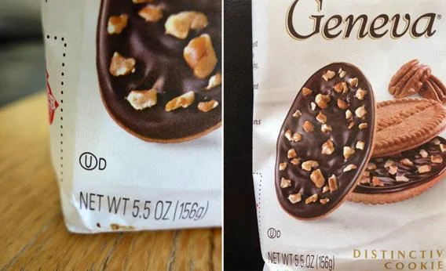First, the “U” in a circle, followed by a “D,”.“OU” stands for Orthodox Union, a Kosher certification. The “D” that follows indicates that the product contains dairy.

Figure : The OUD sign.

1. There are also Halal marks, but in America these are much less common.
2. Ominous cross-hairs that occasionally appear on packaging. These “are register marks, also called crossmarks or position marks,” says Christenson. “They help make sure the colors are aligned”.
3. 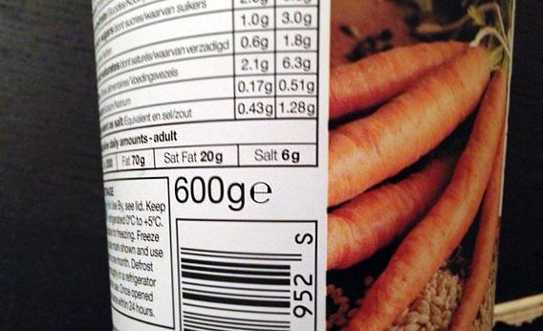The e sign found in many supermarket products signifies that the product complies with European Union regulations on the accuracy of the weight or volume measurement on the package. So, if a bottle says “500ml e,” then it means that the EU approves of how that 500ml claim is calculated.

Figure : The 'e' sign.

Figure : The crosshairs crossmarks sign.